Scraped data Metrics

1. Playwright

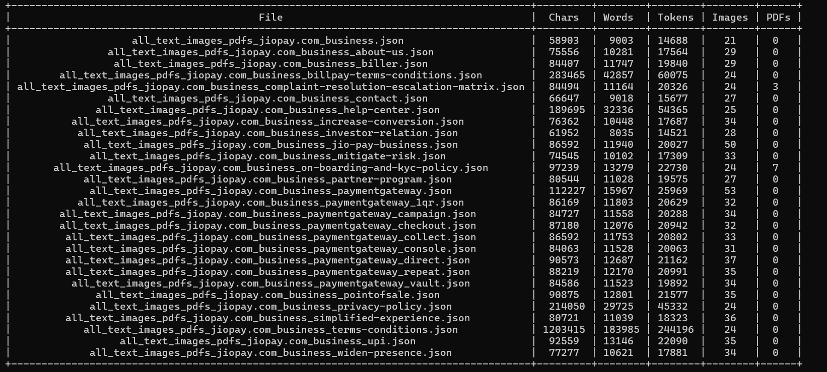

1. Puppeteer



